**Change home directory:**

* We need more disc space so we need to change the home directory.
* And also based on the project requirement.

**How to change the home directory?**

Step – 1:

* Start Jenkins [how? Go to command prompt and move to the location where jenkins.war is located. Then type the command **java –jar jenkins.war**]
* Then go to browser and type **localhost:8080**
* Login to Jenkins using credentials.

Step – 2:

* 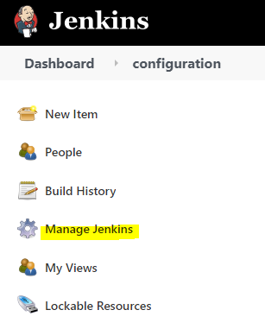Now in the Jenkins to the left you can see **manage Jenkins** click on it.

* Then click on the **configure system.**

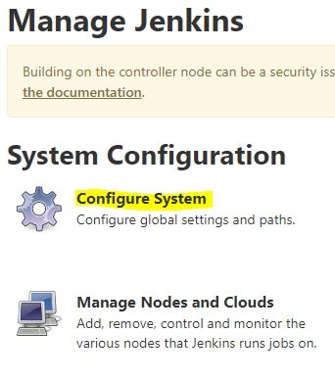

* Now you can see the home directory where the Jenkins is located.

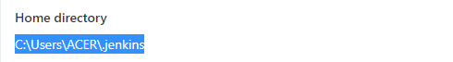

Step – 3:

* Now go to the folder where Jenkins.war is located in your file manager
* And create a new folder named as JenkinsHome

Copy paste t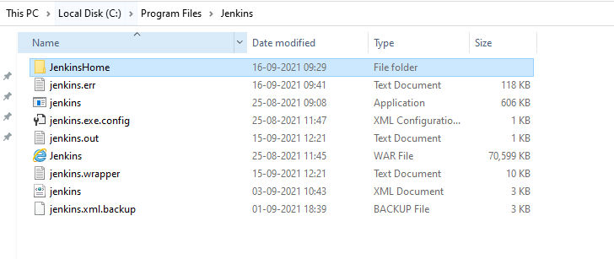

* Then go to the location where .jenkins folder is located and copy all files and folders and paste it in the newly created folder named **JenkinsHome.**
* Then go to environment variable and **add the new variable in system variable section JENKINS_HOME** and copy paste the path where the JenkinsHome folder is located.

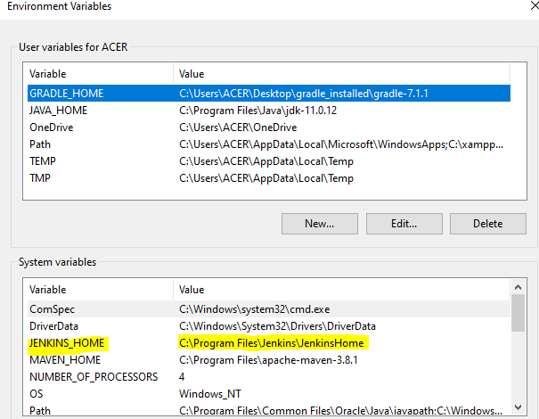

* If in case you already have JENKINS_HOME variable then just edit it to the new location where JenkinsHome folder is located.
* Now you will have Jenkins inside the tomcat.

**Command line interface:**

* Here we will see to control Jenkins from command line.
* If we are using command line interface what are the advantages?
* It becomes easier, faster and memory management become efficient.

How to start it?

Step – 1:

* Start Jenkins using the command **java –jar Jenkins.war**

Step – 2:

* Go to browser and login to your Jenkins.

Step – 3:

* Once Jenkins is open, go to manage Jenkins
* Inside which select **configure global security.**
* Make sure **enable security** is checked.
* If not check it and click and apply and save.

Step – 4:

* Once it is done now go to your dash board.
* And in the url append /cli/
* Then you will be taken to the page of Jenkins cli.

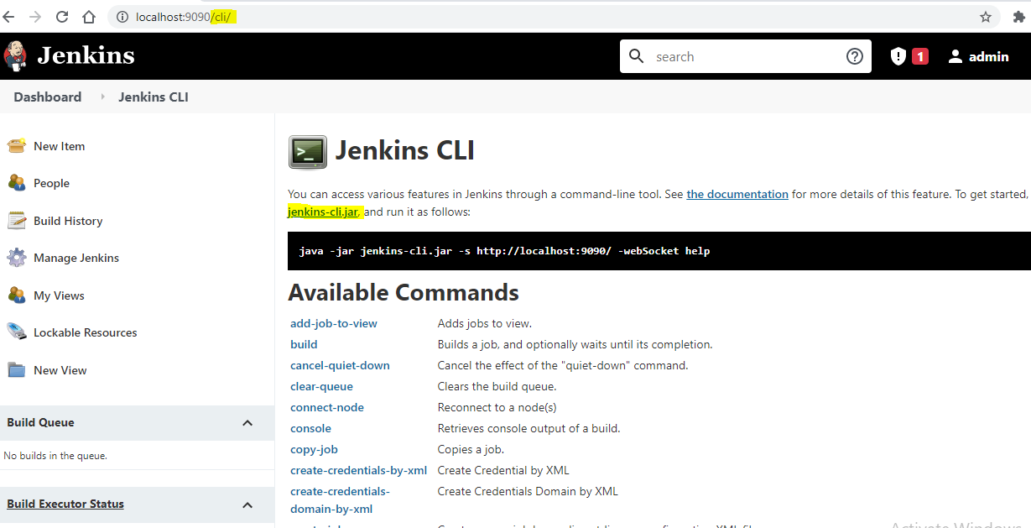

Fig jecli

* Here you can see the link to download the Jenkins cli click on it and download.
* Place the jar file wherever you want on your system.
* And now again open a command prompt and go to the location where Jenkins-cli.jar file is placed on your system.
* And come to the browser again which is shown in the above figure [jecli].
* And you can see some commands using which we can actually work on with the Jenkins using command prompt.
* For instance to know whether it works or not let us try with one available command shown.

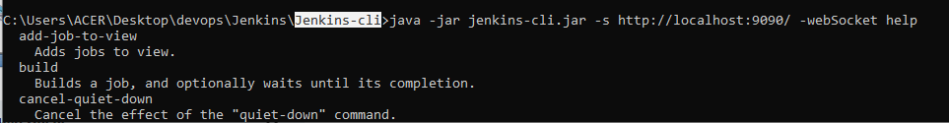

* You can see the command that I have written, this command will available in the browser i.e

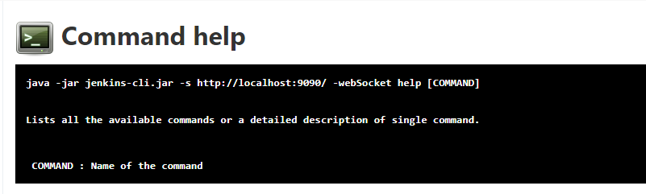

**Creating a new user:**

* Firstly you will be logged in as admin.
* Now you need to create a new user, so how you can do it?
* Yes, first in your Jenkins go to the **manage Jenkins** option in the browser.
* Then in this search for the option **manage users**

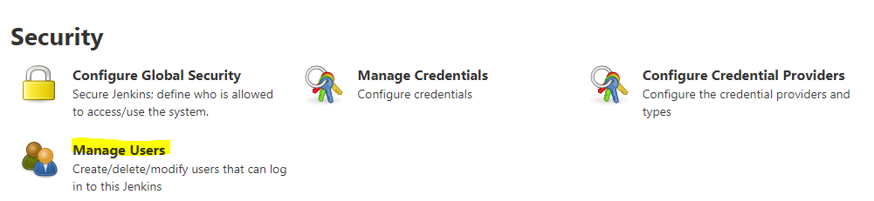

* Click on this and you will see all the users available. And if you wish to add any new user then in the left side of the same page you can see the option create user click on it.

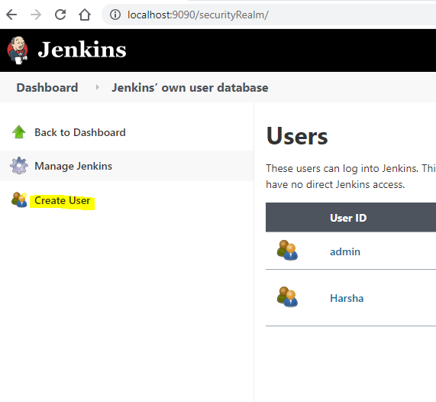

* Then you will be given an option to create the new user.

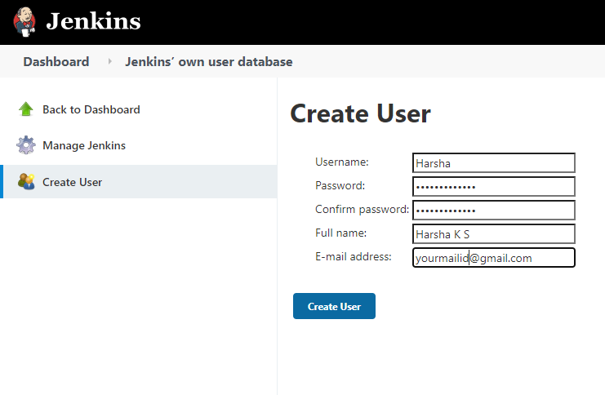

* After creating the user you can logout and login with the user you have created.

**Managing the roles**

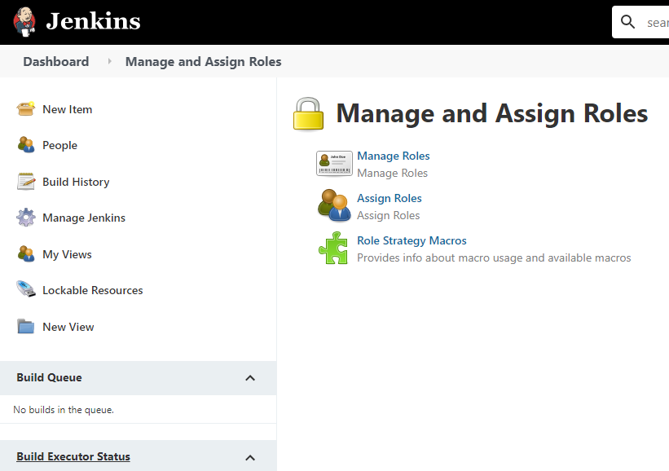

* Select the option that is manage the Roles initially
* Then you have to create some roles in three different section i.e. global roles, item roles and node roles.

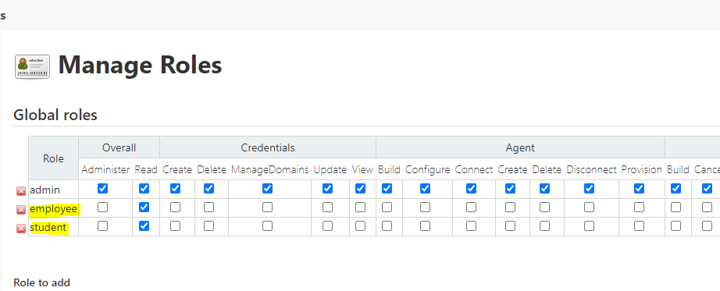

* You can add roles using the option that is given to add the role at the bottom.

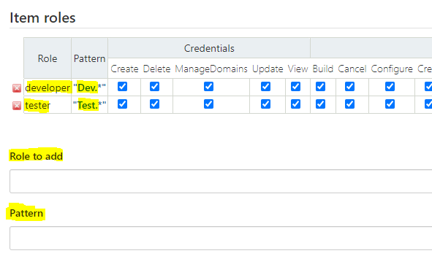

* Now you are seeing the item role which is used to add the role for the project, i.e. where a developer or a tester or a devops engineer.
* Pattern is very important because based on which the user will be categorized as developer or tester.

**Assigning the roles**

* Here we are going to assign the roles to each and every user.

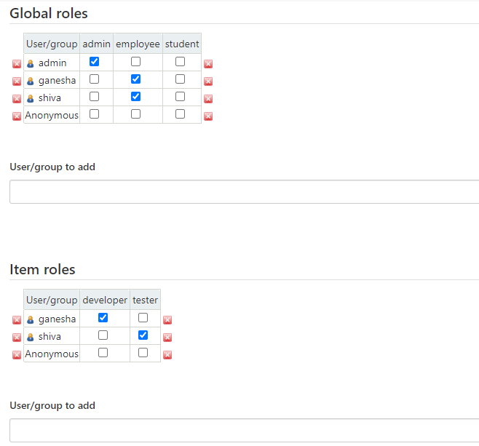

* As an admin you have to assign the roles to the user like in global roles you need to specify him saying whether is he an admin or employee or a student.
* The then in the project what is his role, either developer or the tester.
* Then we will create some jobs.
* And remember the pattern that you have used to create assign the roles.
* Then login with the other user account and you will have to see the jobs/ items that belongs to only his role.
* Which means, if the user is given the item role as developer then the projects/ items/ jobs related to the developer only should be visible.